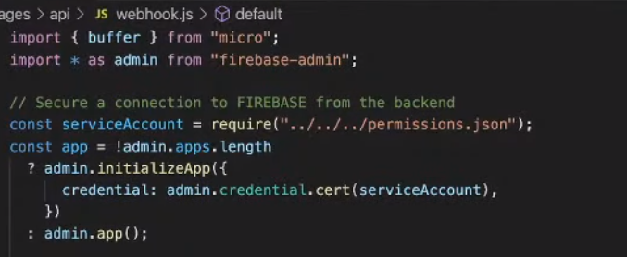

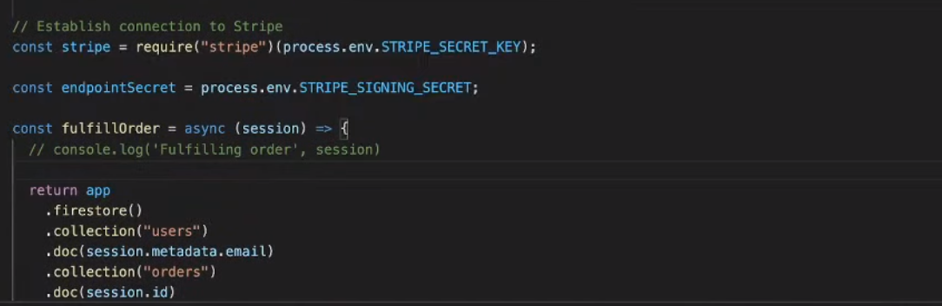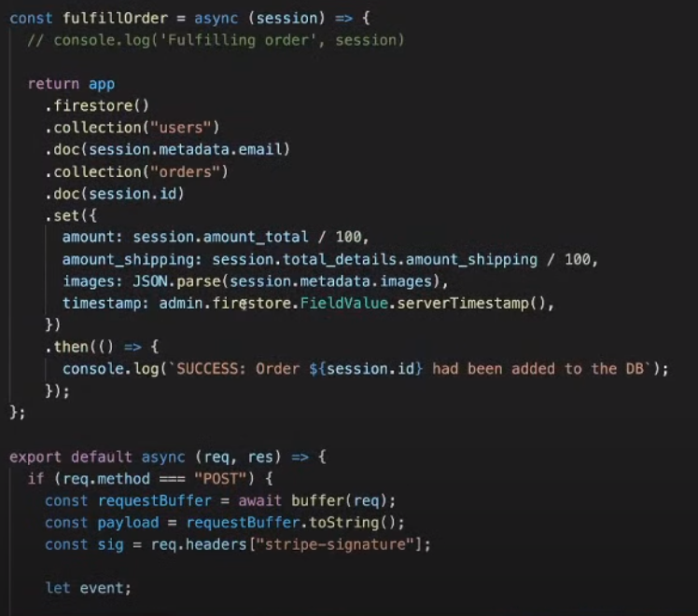

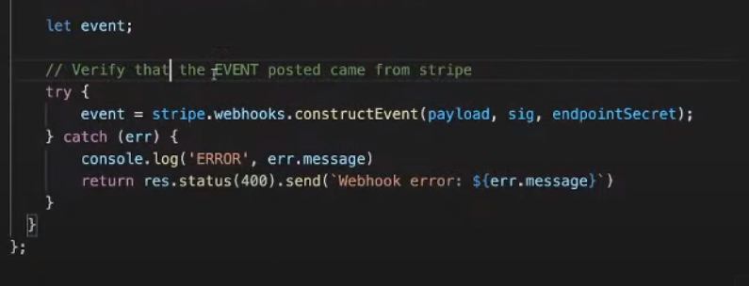

https://youtu.be/4E0WOUYF-QI?t=6532

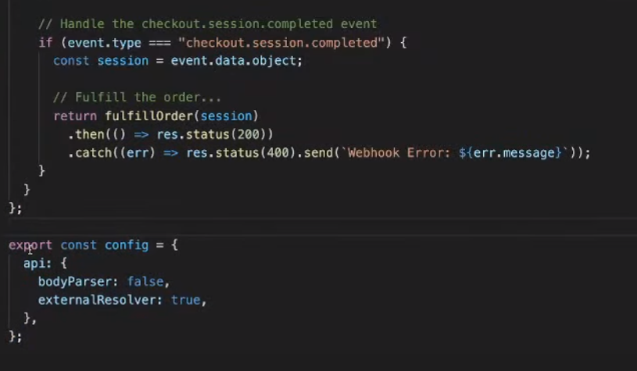

//rules_version = '2';

//service cloud.firestore {

// match /databases/{database}/documents {

// match /{document=**} {

// allow read, write: if false;

// }

// }

//}

rules_version = '2';

service cloud.firestore {

match /databases/{database}/documents {

match /{document=**} {

allow read, write: if request.auth != null;

}

}

}